**ASSIGNMENT-1**

|  |  |
| --- | --- |
| **NAME** | **RIZWAN AHAMED** |
| **TEAM ID** | **PNT2022TMID37442** |
| **PROJECT TITLE** | **IoT Based Safety Gadget for Child Safety Monitoring and Notification** |

int triggerPin = 7;

int echoPin = 6;

unsigned long duration;

int distance;

int pinSensor =2;

int pinLed =12;

int pinBuzzer =13;

int pirSensor =0;

void setup()

{

pinMode(triggerPin, OUTPUT);

pinMode (echoPin, INPUT);

Serial.begin(9600);

pinMode(pinSensor, INPUT);

pinMode(pinLed, OUTPUT);

pinMode(pinBuzzer, OUTPUT);

}

void loop()

{

digitalWrite(triggerPin, LOW);

delayMicroseconds(2);

//clearing the trigger

digitalWrite(triggerPin, HIGH);

delayMicroseconds(10);

digitalWrite(triggerPin, LOW);

// capturing the time duration for sound wave to travel in microseconds

duration = pulseIn(echoPin, HIGH);

distance = 0.01749 * duration;

Serial.print(distance);

Serial.println("cm");

pirSensor = digitalRead(pinSensor);

if (pirSensor == HIGH)

{

digitalWrite(pinLed, HIGH);

tone(pinBuzzer, 500, 250);

}

else {

digitalWrite(pinLed, LOW);

}

delay(7);

}

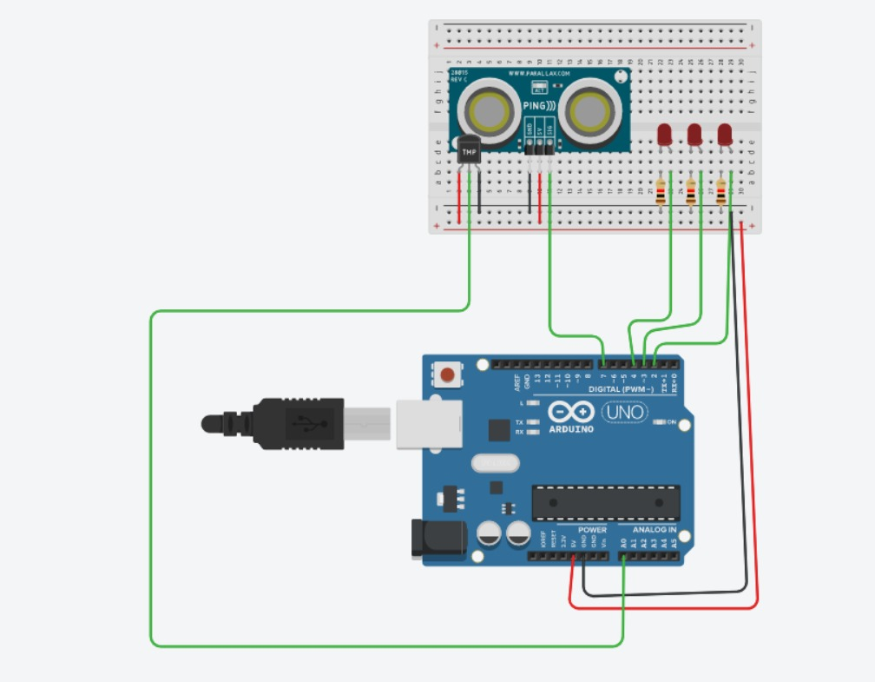

**OUTPUT**

**0cm**